CLACKAMAS RIVER WATER

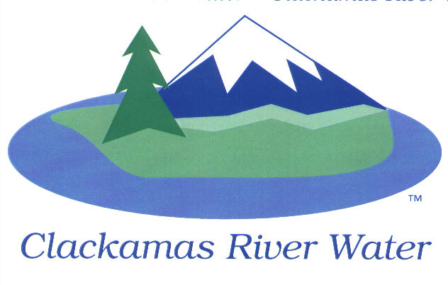
BOARD OF COMMISSIONERS
SPECIAL MEETING & REGULAR MEETING
Held at 16770 SE 82nd Dr.
December 10, 2015

AGENDA

6:00 pm Regular Board Meeting
Please sign the attendance sheet. Members of the public are welcome to speak for a maximum of three minutes. Public comment provided at the beginning of the agenda will be reserved for comment on agenda items, special presentations, letters and complaints. Public comment as listed at the end of the agenda will be for the purpose of “wrapping up” any remaining concerns.
SPECIAL MEETING
Call to Order, Pledge of Allegiance and Roll Call – Hugh Kalani, Board President
CRW Board invites the public to listen and comment on the Southside Service area project and the bond funding of the project
Informational Item
- Overview of the Southside Service Area Project- Carol Bryck, CFO; Bob George Chief Engineer
- Public Comment

Adjourn
REGULAR MEETING @ 6:00 p.m.
Call to Order– Hugh Kalani, Board President
  - Approval of the Agenda

Public Comment (see blue box at the top of the agenda)
Presentations
Audit Presentation – Julie Desimone, Moss Adams
Insurance presentation- Jeff Griffin, Wilson-Heirgood

Action Item
- Acceptance of the audited financial statement for Fiscal Year 15 - Carol Bryck, CFO
- Project Acceptance- SE Tolbert Street Waterline Relocation, CIP 14-5148 –Adam Bjornstedt, Principal Engineer
Next page

Consent Agenda
CA-1: Gross Payroll and Accounts Paid: November 2015
CA-2: Cash Position and Transfers: November 2015
CA-3: Camp Withycombe, Clackamas Oregon- CRW “Rules and Regulations” Chapter 8 & 11 – Temporary Irrigation Water Service exception request – Bob George, Chief Engineer
Informational Reports
- Southside Service Area Project update – Adam Bjornstedt, Principal Engineer
- MANAGEMENT REPORT – Lee Moore Sr., General Manager
- Public Comment (see blue box at the top of the agenda)
Commissioner Business
- Commissioner Reports and Reimbursements –Naomi Angier, Ken Humberston, Hugh Kalani, Dave McNeel, & Larry Sowa

Adjourn

The meeting location is accessible to persons with disabilities. A request for accommodations for persons with disabilities should be made at least 48 hours before the meeting to Adora Campbell (503) 722-9226.

