CLACKAMAS RIVER WATER
1
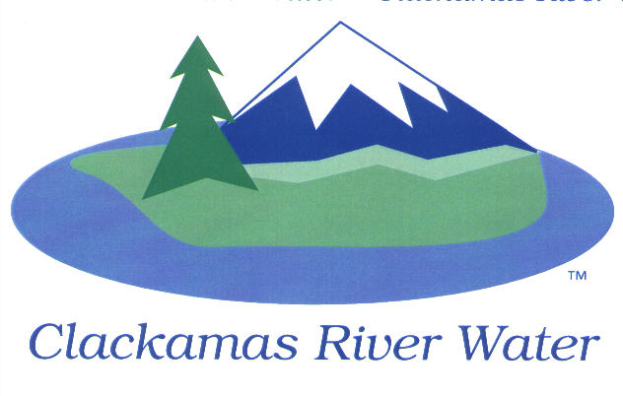
BOARD OF COMMISSIONERS
REGULAR MEETING
November 13, 2014

AGENDA

6:00 pm – 8:00 pm
Please sign the attendance sheet. Members of the public are welcome to speak for a maximum of three minutes. Public comment provided at the beginning of the agenda will be reserved for comment on agenda items, special presentations, letters and complaints. Public comment as listed at the end of the agenda will be for the purpose of “wrapping up” any remaining concerns.
REGULAR MEETING @ 6:00 p.m.
Call to Order, Pledge of Allegiance and Roll Call – Larry Sowa, Board President
  - Approval of the Agenda
Public Comment (see blue box at the top of the agenda)
Action Items
- Acknowledgement of FY 2014 Comprehensive Annual Financial Report (CAFR) and Audit – Julie Desimone, Moss Adams, LLC
- Resolution 04-2015: Amending Cooperative IGA with Sunrise Water Authority to Remove Indemnity Language in Sections 13.1 and 13.2 – Lee Moore, General Manager
Consent Agenda
CA-1: Gross Payroll and Accounts Paid: October 2014
CA-2: Donation of Assets: Consider acceptance of waterline easement and donation of asset granted by Kurt and Lisa Morris - Bob George, Chief Engineer
CA-3: Cash Position and Transfers – October 2014
Informational Reports
- Discussion to Consider Establishing a Biennial Budget Beginning July 1, 2015 for BN 2015-2017 – Carol Bryck
- ENGINEERING REPORT
  - Project Status: Carver Bridge Phase 2 – Adam Bjornstedt, Principal Engineer
- MANAGEMENT REPORT – Lee Moore Sr., General Manager
- Public Comment (see blue box at the top of the agenda)
Commissioner Business
- Confirm Dates for November & January Work Sessions – No Work Session in December
- Commissioner Reports and Reimbursements
Adjourn

