CLACKAMAS RIVER WATER
1
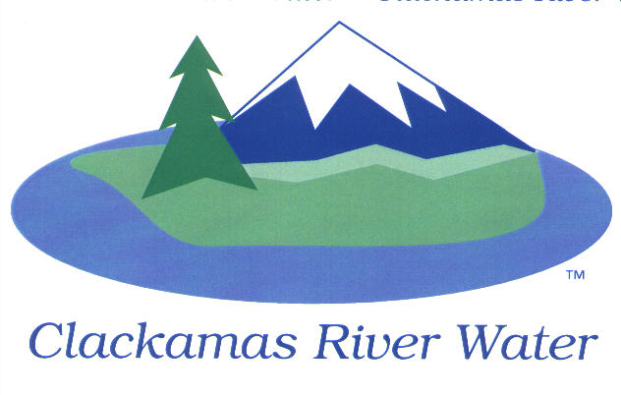
BOARD OF COMMISSIONERS
REGULAR MEETING
January 8, 2015

AGENDA

6:00 pm – 8:00 pm
Please sign the attendance sheet. Members of the public are welcome to speak for a maximum of three minutes. Public comment provided at the beginning of the agenda will be reserved for comment on agenda items, special presentations, letters and complaints. Public comment as listed at the end of the agenda will be for the purpose of “wrapping up” any remaining concerns.
REGULAR MEETING @ 6:00 p.m.
Call to Order, Pledge of Allegiance and Roll Call – Larry Sowa, Board President
  - Approval of the Agenda
Public Comment (see blue box at the top of the agenda)
Action Items
- Resolution 06-2015: Second Reading to Amend Board Policy Section 1.9, by title only, Agenda Preparation. This will change the number of days prior to the Board Meeting agenda items must be submitted to the Board Secretary – Lee Moore, Sr., General Manager
- Resolution 07-2015: Second Reading to Amend Board Policy Section 1.10, by title only, Preparation for Board Meetings. With this change, the Agenda will now serve as the public notice - Lee Moore, Sr., General Manager
- Resolution 09-2015: First Reading to Amend Board Policy Section 3.2, by title only, Budget Committee. – Membership and Responsibilities. Due to the Biennial Budget, this change will extend Budget Committee terms to four years – Lee Moore, Sr., General Manager
- Resolution 10-2015: Appoint Budget Officer for 2015-2017 Biennium – Carol Bryck, CFO
- Resolution 11-2015: Adopt Intergovernmental Agreement with the City of Milwaukie for billing services – Carol Bryck, CFO
- PGE-DSG Agreement for Emergency Generator: Approve Revised 10-year Agreement - Adam Bjornstedt, Principal Engineer
- Cross-Connection Control Ordinance: First Reading to Adopt Revised Ordinance (01-2015) - Adam Bjornstedt, Principal Engineer
- Resolution 12-2015: Appointment of Budget Committee Members. CRW needs to appoint 2 citizen members to the budget committee. - Carol Bryck, CFO (May occur in Feb)
Consent Agenda
CA-1: Gross Payroll and Accounts Paid: December 2014
CA-2: Cash Position and Transfers
NEXT PAGE

Informational Reports
- Presentation of proposed budget calendar and notification to Board of available Budget training opportunities- Carol Bryck, CFO
- MANAGEMENT REPORT – Lee Moore Sr., General Manager
- Public Comment (see blue box at the top of the agenda)
Commissioner Business
- Commissioner Reports and Reimbursements
- Discussion on Beaver Creek Hamlet - Dave McNeel

Adjourn

