1
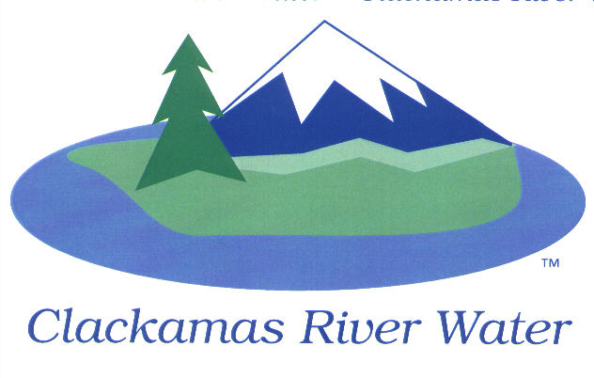

CLACKAMAS RIVER WATER
BOARD OF COMMISSIONERS
REGULAR MEETING
August 14, 2014

AGENDA

6:00 pm – 8:00 pm
Please sign the attendance sheet. Members of the public are welcome to speak for a maximum of three minutes. Public comment provided at the beginning of the agenda will be reserved for comment on agenda items, special presentations, letters and complaints. Public comment as listed at the end of the agenda will be for the purpose of “wrapping up” any remaining concerns.
REGULAR MEETING @ 6:00 p.m.
Call to Order, Pledge of Allegiance and Roll Call – Larry Sowa, Board President
  - Approval of the Agenda
Public Comment
Public Comment – (see blue box at the top of the agenda)
Action Items
Convene the Local Contract Review Board
- Emergency Power and Electrical Upgrades Project: CM/GC Evaluation Report
– Adam Bjornstedt, Engineering Manager
- Public Comment
Consent Agenda
CA-1: Gross Payroll and Accounts Paid: July 2014 – Carol Bryck
Informational Reports
- FINANCIAL REPORT – Carol Bryck
- Accounts Receivable/Aging Balance – July 2014
- Cash Position and Transfers – July 2014
- FY 2014 Budget to Actual Update – June 30, 2014
- 4th Quarter Line Item Review
- MANAGEMENT REPORT – Lee Moore Sr., General Manager
- Public Comment (see blue box at the top of the agenda)
Commissioner Business
- Commissioner Reports and Reimbursements

Adjourn Regular Meeting

NEXT PAGE

EXECUTIVE SESSION @ 7:00 p.m.
- Discuss information or records that are exempt by law from public inspection pursuant to ORS 192.660 (2) (f) and 192.502 (9)
- Consult with counsel concerning the legal rights and duties of a public body with regard to current litigation or litigation likely to be filed pursuant to ORS 192.660 (2) (h)

Recess or Adjourn Executive Session

